**13 August - 31 October**

2014

**Tabcorp**

08

**Fall**

Final Report on Internship Project of Tabcorp

Lu Chen

Abstraction In this report, the internship-working environment will be introduced firstly. After that, the detailed tasks that are done in the internship will be reported with detailed explanations of solutions. The internship goals and their reflections will reported at last with help of descriptions of typical routine tasks during the internship.

Signature

CHRIS DE LORENZO LEON JIANG LU CHEN

Introduction 3

Internship Working Environment Description 3

Working Experience in Tabcrop 3

Projects Introduction 4

Requirements and Scope 4

Identify the process for landing Google 4

Dashboard 4

DDOS attack 4

Design and Modeling 5

Dashboard 5

Bravo 5

SSH 5

HTTP API 6

Sending API 6

Receiving API 6

Display 7

CAM 8

SSH 8

Display 8

Spectrum and Trackside 9

Solution Flow 9

Display 9

Learning and Reflection 9

Aims 10

Reflection 10

Standup Meeting 10

Tasks Discovery and Allocation 10

Task Progress 10

Tech Show and Task Review Presentation 11

Special Tasks 11

Agile Training 12

Appendix 12

Dashboard Deployment Instruction 12

Installation of Ruby Environment 12

Download Source Code 12

Install Dependencies 12

Startup dashboard 12

Dashboard Configuration File Instruction 12

Grey out Configuration 12

Environment Configuration 13

# Introduction

The report is dedicated to reflect internship in Tabcorp from student perspective. It will firstly introduce the internship environment; then explains how tasks are assigned and processed during the internship period in great detail; after that the lessoned learn and experience will be discussed.

# Internship Working Environment Description

Tabcorp is big organization. There is no concise approach to describe its structure. In this part, the structure of the internship related working environments would be explained.

The internship is conducted in performance testing team that is belonged to testing team in Tabcorp. However, in order to conduct the internship works, communications and cooperation involve with digital teams as well. The overall working environment can be demonstrated as following pictures.

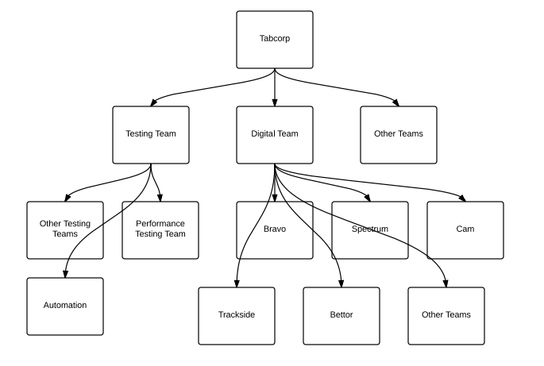

Figure Internship Working Environment Structure

# Working Experience in Tabcrop

In this part, all tasks done in Tabcorp will be demonstrated via detailed software design documentation.

## Projects Introduction

There are three major projects during the internship

* Identify the process for landing Google job.
* Build dashboards
* Launch a DDOS attacks to the Tabcorp system.

Those three projects together will develop skills from perspectives of job hunting, techniques and communication.

The procedures of discovering those projects are via have meetings and talks with origination supervisor and testing team members.

All projects are conducted via agile approach.

In the next part, scope of those projects will be explained.

## Requirements and Scope

### Identify the process for landing Google

* Communicate with Google HR
* Retrieve job list
* Apply interesting positions

### Dashboard

* Display up/down status of bravo in all environment
* Display CAM host status
* Display trackside host health status
* Display spectrum host health
* Display total bets sold
* Display total sports bets sold
* Display bravo version
* Display number of active terminals
* Display XB-Link status
* Display master/slave and simplex/duplex
* Display other interesting widgets

### DDOS attack

* Launch a SYBN flood DDOS attack to tab.com.au

Because DDOS and landing Google are just short period special tasks they will be discussed in reflection parts; in the next section of this report, the solutions of dashboard components will be explained in great detail.

## Design and Modeling

### Dashboard

#### Bravo

##### SSH

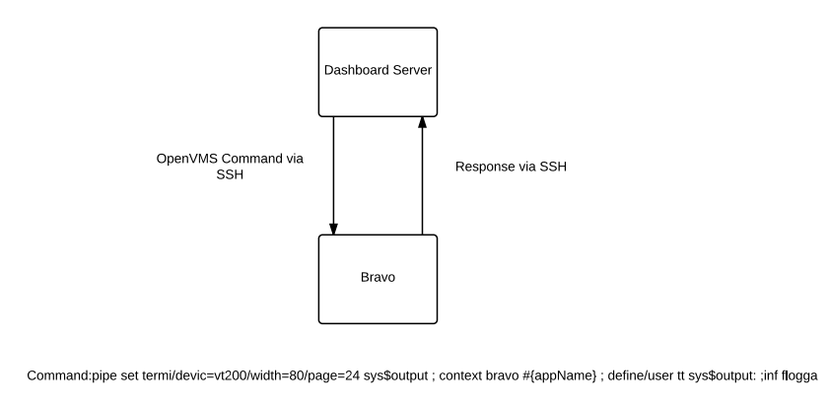

Figure Bravo health status check data flow

As displayed in upper figure, the ruby server will firstly send a command to the Bravo server. The command including following actions:

* Configure the OpenVMS output setting (SSH via ruby is different to SSH software and the environment is not a real terminal)
* Change the context environment to a specific Bravo application
* Reconfigure the OpenVMS out put setting (flogga output is different from normal OpenVMS output and it will continuously send data until it is terminated)
* Execute “inf flogga”

Those actions are executed in sequence. The ruby server will receive the output of “inf flogga” after execution. The ruby server will judge whether the Bravo is dead or alive via following logic show in flowing figure.

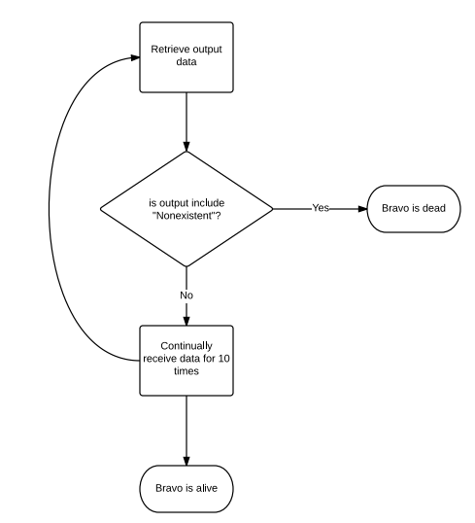

Figure Bravo dead or alive logic

The process described previously only for a single Bravo application. The actual solution iterates them for all Bravo applications in different environments for each project.

##### HTTP API

In order to fetch rich information from Bravo, digital team provides a web service for dashboard server to retrieve them. The JSON API is demonstrated in following tables.

###### Sending API

|  |  |
| --- | --- |
| Fields | Contents |
| function | GetBravoMetrics |
| transactionId | f132f893-2d24-4d40-9115-d01e04ebd627 |
| action | Request |

Figure Sending Data API

###### Receiving API

|  |  |
| --- | --- |
| Fields | Sample Contents |
| function | GetBravoMetrics |
| transactionId | f132f893-2d24-4d40-9115-d01e04ebd627 |
| action | Response |
| activeTerminals | 1 |
| bravoVersion | 79.0.0 BRAVO on IA64 2015-Feb Release [CLCM, ICE Phase 2, ...] - built 17-SEP-2014 |
| error | false |
| hostMode | Simplex |
| hostName | THINK |
| hostRole | Master |
| hostStatus | UP |
| totalFixedOddsBetsSold | 3 |
| totalParimutuelBetsSold | 33 |
| xbLinkStatus | UP |

Figure Receiving Data API

##### Display

Displays of information of those data in dashing framework are via customized widgets

* Bravotext
* Bravolist
* Text_number

#### CAM

##### SSH

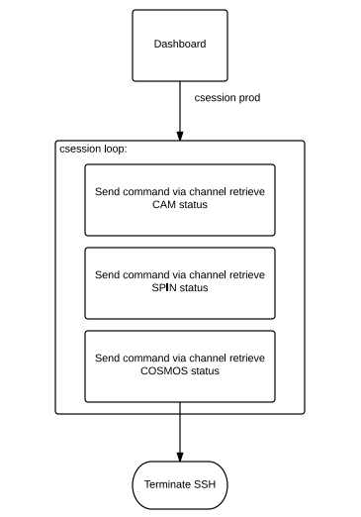

Figure CAM SSH data flow chart

The data flow for retrieving raw CAM status data are shown in upper figure. There are differences between CAM and Bravo environment and that results in

* CAM do not need configure output because it running on Linux
* After send command “csession prod” the CAM running in a loop waiting for further commands
* The SSH will not end and the further action need send via channel rather than SSH command line

After successfully retrieving raw data, the dashboard displays CAN health status via cam, spin and cosmos. The logic of processing those raw data are demonstrated via flowing pictures:

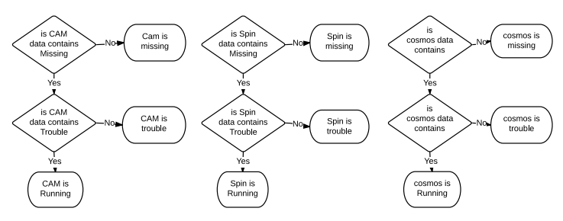

Figure CAM health status logic

##### Display

The information is displayed via customized widget named Camhost.

#### Spectrum and Trackside

Unlike other solutions, the Spectrum and Trackside needs prerequisites to ensure the solution works.

Those prerequisites include

* Define workable terminal and outlet in bravo
* The Bettor version is compatible among Bravo, Spectrum and Trackside
* Workable OpenVMS DCL script for buying bets from spectrum and trackside via Bettor

##### Solution Flow

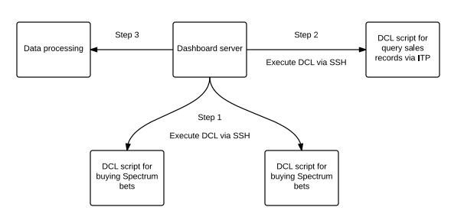

Figure bets sale availability check solution flow

The upper figure shows the overall solution steps. The sample DCL script for buying bets and query sales records via ITP can be referred to appendix.

After data retrieval, the bets sale availability can be easily reflected via ITP query result.

This solution is very unstable because the environment always changes in Tabcorp and if the environment changes, DCL scripts for buying bets need to be updated and distributed to all bravos so that to guarantee the solution can works.

##### Display

The information is displayed via customized widget named Trackside.

# Learning and Reflection

During the internship period, I was exposed to a complex working environments and several different technologies. As a result, my abilities are improved by all means. In this part, I will firstly discuss aims for this internship and then discuss and reflect my experience regarding those aims.

## Aims

The overall goal for the internship we discussed at the firstly day is

* After internship I am competitive to find a job in Google related to data mining

However, in order to achieve that goal I need develop skills including

* Web development
* Performance testing
* Cloud computing
* Data mining
* Agile development

Besides, I need to learn and experience working in agile management and further improve communication skills covers

* Verbal: meeting, stand up, presentation and interview
* Writing: email and documentation

## Reflection

The major project—dashboard—drives me develop most of those skills imperceptibly. In this part, I will discuss it via describe several typical activities during the internship.

### Standup Meeting

The normal working day start with agile learning—the standup meeting. On the other hand, the standup meeting is also a good opportunity to learn professional verbal communication. During the meeting, I can that learn how professionals report progress, discuss tasks dependencies and mitigate conflicts; besides, I can also learn project manager skill via how the manager mediates conflict, clear blockers and allocate resources. In short, the daily standup meeting can help me improve verbal communication skills significantly and practice agile knowledge.

### Tasks Discovery and Allocation

In Tabcorp, as an Internship student, I do not be forced to do some tasks directly. Reversely, I am in charge of find potential project I am interested in. That is the most excite part in the internship. It drive me from a passive accepter become a positive explorer. In order to find tasks to further the project, I book meeting time with people from different team; via that, I learned the structure of the Tabcorp and basic workflow; besides I also learned what the are currently doing hence identify potential tasks I possibly do. After that, I will have meeting with supervisor; we will evaluate discoveries and decide tasks.

### Task Progress

The dashboard involved different technologies and team. As a result, finish task needs great amount of communications. Similar to the task discovery, I need book meeting time with professionals from different team; tell them what I am doing and see if I can get help from them. Those meeting are valuable to me. Because as a fresher, recommendations from experts can help me learn basics quickly hence have the ability to find solutions for tasks.

On the other hand, in order to implements solution, I need to learn several technologies independently because this project involved new technologies. Those learning experience are extremely valuable to me. As a student, I seldom learn and use professional framework before while in this project I learn one of the most popular dashboard framework dashing; other than that, I also learned ruby based web development solutions, coffee script and advanced web page layout programming skills.

In short, each task helps me improve my communication skill greatly; besides, I develop very strong knowledge regarding web development; at last, the procedures of program raw data to visual representation, actually give me the basic ideas of data mining.

### Tech Show and Task Review Presentation

Once a task is done, the review presentation further develops my presentation skill. It typically took 2 hours to prepare the presentation. During the presentation, I will demonstrate key feature of the developed tasks. As a requirement, I need to explain very low-level details.

Those kind of tech presentation drive me learn more knowledge. In front of group of ICT professional, anything wrong can be point out and questioned very quickly. The preparation covers more than what I just did and in order to be professional I expend learning a lot.

Feedbacks from ICT professionals are sources of next tasks after have discussion with supervisor.

By the end of the internship, I did several tech presentation; that help me build strong professional presentation skill. The feedback from ICT professionals and supervisor help me improve little by little and eventual cause significant improvement.

### Special Tasks

Besides major tasks, as discussed in previous part, there are other small projects within the internship in Tabcorp.

The DDOS attacks not only help me review C programing techniques at coding stage but also drive me learn advance cloud computing skills at implementation stage—using automated Amazon EC2 instances to launch attacks. In order to monitoring the response of being attacked server, we mining it log files hence analyze the server’s response.

This small project took less than 3 working days but involved with cloud computing, data mining and some kind of performance testing that perfectly achieves what we expected in this internship.

Hunting job at Google, this small project actually change my future life. After several emails communication with one of the HR from Google, I actually get a conditional offer from Google for a PHD research project regarding data search and mining. During this project, I learned how to sell myself before HR and get excellent experiences.

In summary, the period of internship is one of the most unforgettable experiences in my life. It not only boost my technique skills in multiple perspectives to professional level but also greatly improve my communication skill that might be even more important in workplace. The internship goes as our expected and I did my best to program the dashboard that may help my supervisor in their future works.

### Agile Training

# Appendix

## Dashboard Deployment Instruction

### Installation of Ruby Environment

According to the platforms, ruby installation guide can be refereed via following web page:

<https://www.ruby-lang.org/en/installation/>

### Download Source Code

Please ensure you Github account have the privilege to access TabDigital. Please use following command to clone the dashboard code from Github to your local computer:

*git clone https://github.com/TabDigital/dashboard.git*

### Install Dependencies

After download the source code, please go to the source code root directory and run command

*bundle install*

### Startup dashboard

After install the dependencies please run following command to run the dashboard

*dashing start*

## Dashboard Configuration File Instruction

### Grey out Configuration

The configuration is in CVS format. Each line defines a bravo app that want be greyed out with

*“Server name”, “bravo application name”*

for instance

*black, sitn*

means greys out sitn in black.

### Environment/Project Configuration

The configuration file follows CVS format. Each line defines projects for an environment.

*“environment name”,”project1”,”project2”,”…”*

For instance

*Congo, project1,Alcatraz*

Means add Project and Alcatraz to environment Congo.